DBMS LAB1
Anmol Keswani_ECS_D668
AIM: To perform and understand fundamental DBMS operations, including database creation , table management, data manipulation, modification, and retrieval using MySQL.
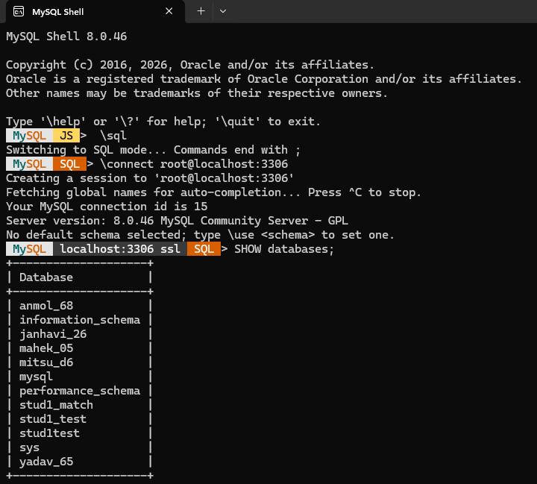

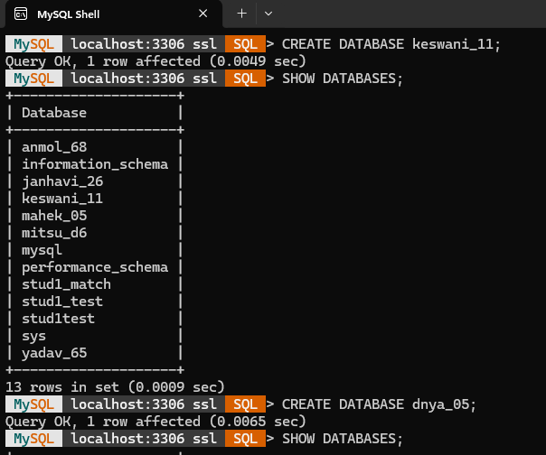

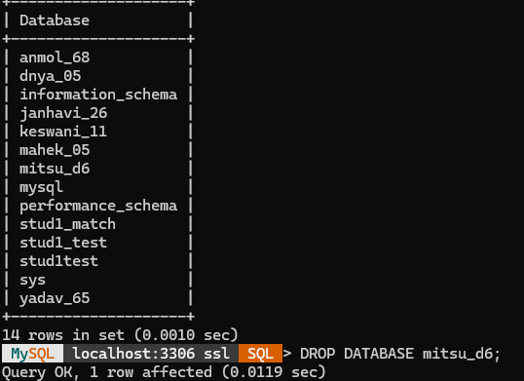

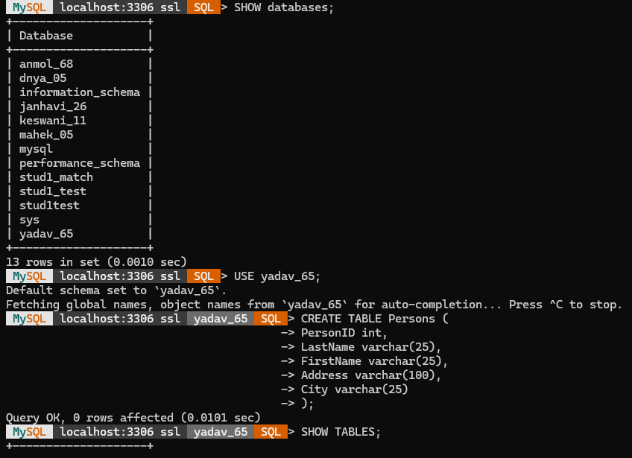

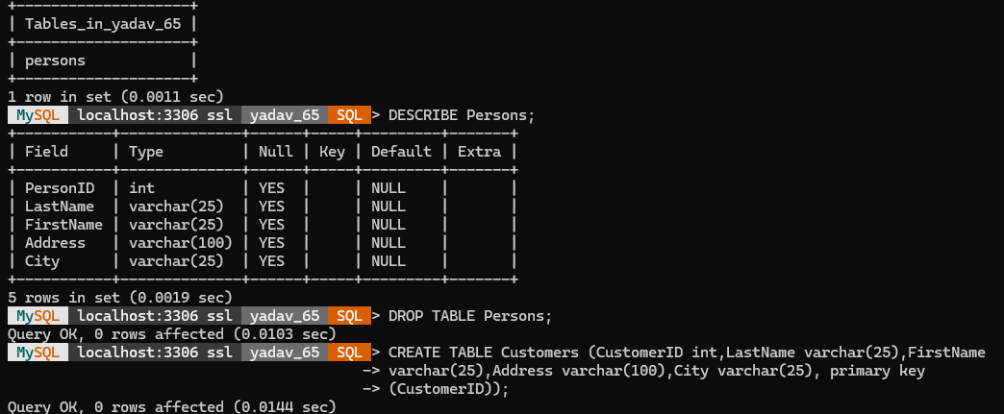

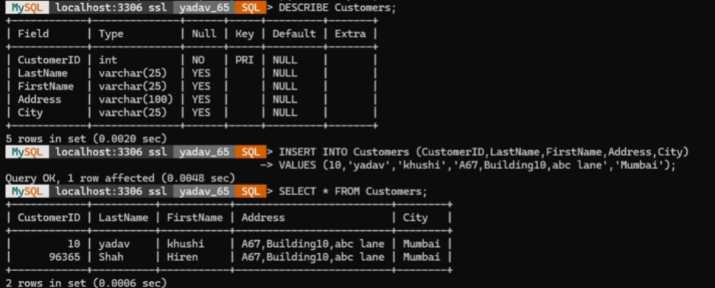

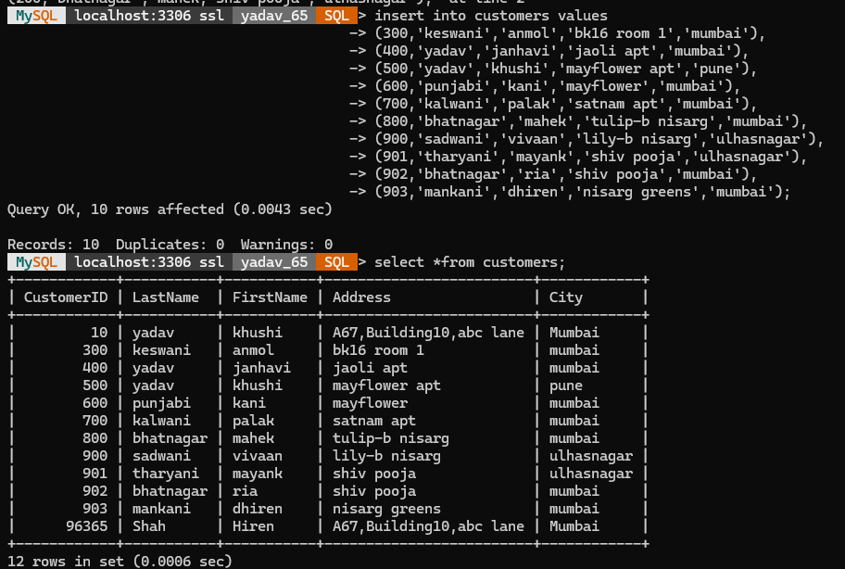

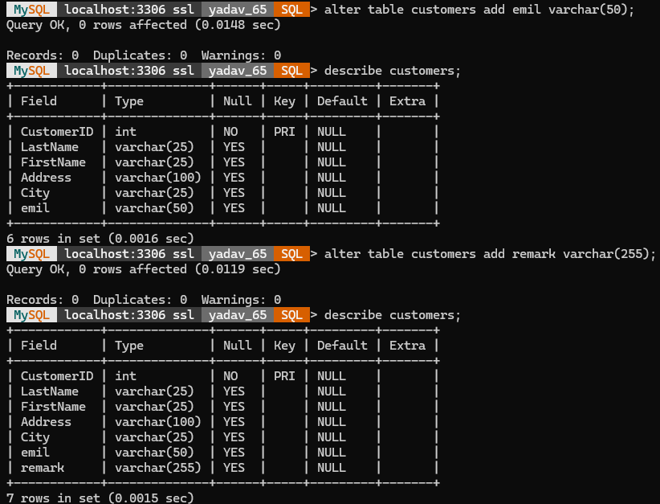

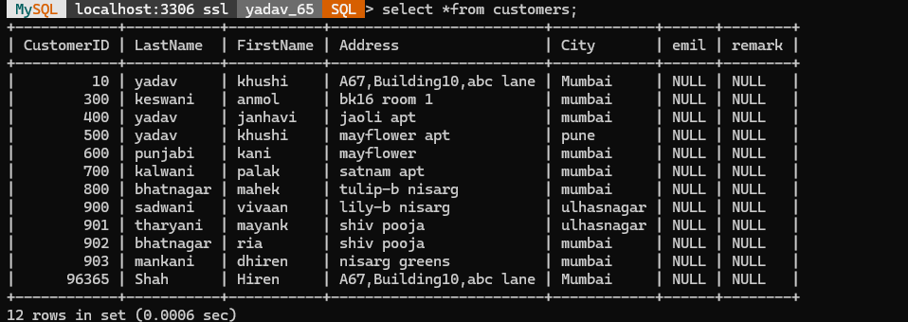

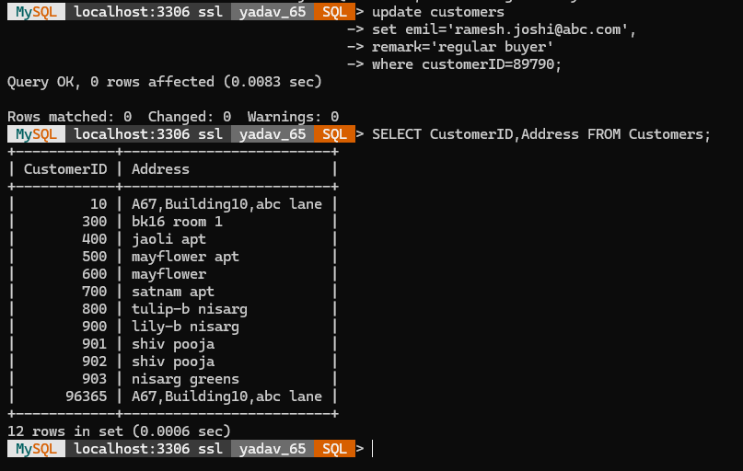

1. What is a Database? Why do we need a Database Management System such as MySQL?
A database is an organized collection of related data that allows information to be stored, managed, and retrieved efficiently. It helps users store large amounts of data in a structured manner.
A Database Management System (DBMS) is software used to create, store, organize, retrieve, and manage data in a database. MySQL is a popular relational DBMS that uses SQL (Structured Query Language) to work with data.
We need a DBMS such as MySQL because it:
- Stores data systematically and reduces unnecessary duplication.
- Makes data retrieval faster and easier using SQL queries.
- Allows data to be inserted, updated, and deleted efficiently.
- Provides security by controlling access to the database.
- Maintains data integrity and consistency.
- Handles large amounts of data efficiently.
- Supports multiple users working with the database.
In conclusion, a database stores organized information, while a DBMS such as MySQL provides the tools required to manage that information efficiently, securely, and reliably.
2. What is the Difference between CREATE DATABASE, SHOW DATABASES, and DROP DATABASE
- CREATE DATABASE — This command is used to create a new database in MySQL. It provides a separate space where related tables and data can be stored and managed.
Example : CREATE DATABASE college;
- SHOW DATABASES — This command is used to display the list of all databases currently available on the MySQL server. It helps the user view the databases that have been created.
Example : SHOW DATABASES;
- DROP DATABASE — This command is used to permanently delete an existing database from the MySQL server, including all the tables and data stored within it.
Example : DROP DATABASE college;
3. What is a Table in a Database? Explain the Purpose of Rows and Columns.
A table in a database is a structured way of storing related data in the form of rows and columns. It organizes information systematically, making it easier to store, retrieve, update, and manage data. A table generally represents a particular entity, such as students, employees, or products.
- Rows — A row represents a single record or entry in a table. Each row contains complete information about one particular entity. For example, in a student table, one row can contain the details of one student.
- Columns — A column represents a specific attribute or field of the records. It defines what type of information is stored in that column, such as student ID, name, age, or department.
Therefore, rows represent individual records, while columns represent the attributes or fields of those records. Together, they provide a structured and organized representation of data in a database.
4. What is a Primary Key? Why was CustomerID selected as the primary key in the Customers table?
A primary key is a field or a combination of fields used to uniquely identify each record in a database table. Each value of a primary key must be unique, and it cannot contain a NULL value. It helps in identifying individual records and maintaining the integrity and consistency of the data.
CustomerID was selected as the primary key in the Customers table because it provides a unique identity to every customer. Since each customer is assigned a different CustomerID, two customers cannot have the same identifier. It also allows a particular customer's record to be easily identified, accessed, and referenced.
Therefore, CustomerID is suitable as a primary key because it uniquely identifies each customer and prevents duplicate or unidentified customer records.
5. What is the purpose of the VARCHAR and INT data types? Give one suitable example of each.
- VARCHAR is a data type used to store variable-length text or character data. It is suitable for storing information such as names, addresses, email addresses, and other textual values. The number specified in VARCHAR(n) represents the maximum number of characters that can be stored.

Example: CustomerName VARCHAR(50) — stores the name of a customer, with a maximum limit of 50 characters.

- INT is a data type used to store whole numbers or integers. It is commonly used for numerical values such as IDs, age, quantity, marks, or counts. It does not store decimal values.

Example: CustomerID INT — stores the unique numerical identification number of a customer.
Therefore, VARCHAR is used for variable-length text data, while INT is used for whole-number data.

6. What is the Difference between INSERT, SELECT, UPDATE, and ALTER TABLE
- INSERT — This command is used to add new records or rows to an existing table. It is used when new data needs to be stored in the database.
Example : INSERT INTO Customers VALUES (101, 'Rahul', 'Mumbai');
- SELECT — This command is used to retrieve or display data from one or more tables. It allows users to view the required records and information stored in the database.
Example : SELECT * FROM Customers;
- UPDATE — This command is used to modify or change existing data in a table. It is useful when the information stored in one or more records needs to be corrected or updated.
Example : UPDATE Customers SET City = 'Pune' WHERE CustomerID = 101;
- ALTER TABLE — This command is used to modify the structure of an existing table. It can be used to add, modify, or remove columns and make other structural changes.
Example : ALTER TABLE Customers ADD Email VARCHAR(50);
In short: INSERT adds data, SELECT retrieves data, UPDATE modifies data, while ALTER TABLE modifies the structure of a table.
7. Why is the WHERE clause important in an UPDATE statement?
The WHERE clause is used to specify which particular record or records should be updated. It ensures that only the intended rows are modified based on the given condition.
For example:
UPDATE Customers
SET City = 'Pune'
WHERE CustomerID = 101;
Here, only the customer whose CustomerID is 101 will be updated.
If we write an UPDATE statement without a WHERE condition, the specified column will be updated for all the records in the table. This can unintentionally change the data of every row and may result in loss or incorrect modification of important information.
Example:
UPDATE Customers
SET City = 'Pune';
This will change the city to Pune for every customer in the table.
Therefore, the WHERE clause is important because it prevents unintended changes and ensures that only the required records are updated.

